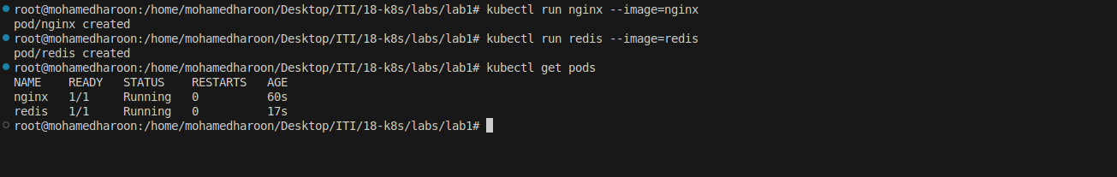
Create a pod with the name redis and with the image redis.

Create a pod with the name nginx and with the image “nginx123”
Use a pod-definition YAML file

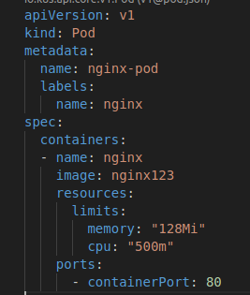

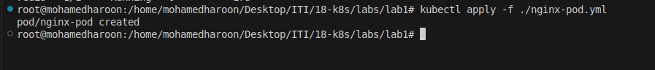
4- - What is the nginx pod status?

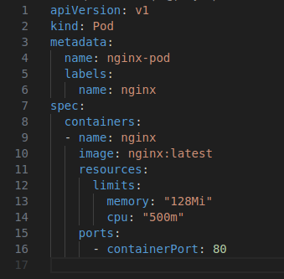
Change the nginx pod image to “nginx” check the status again

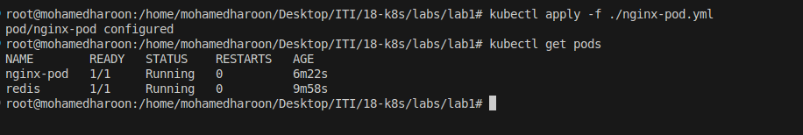

How many ReplicaSets exist on the system?
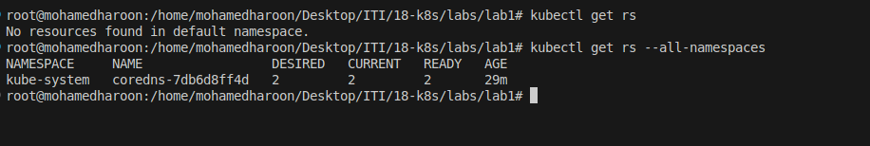

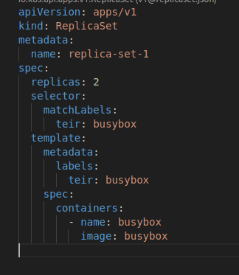
create a ReplicaSet with name= replica-set-1 image= busybox replicas= 2

Scale the ReplicaSet replica-set-1 to 3 PODs.
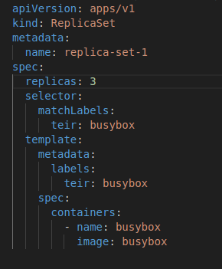

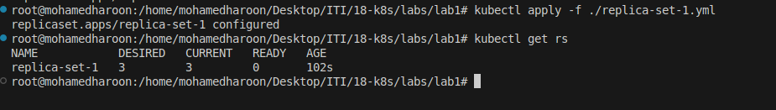

How many PODs are READY in the replica-set-1?
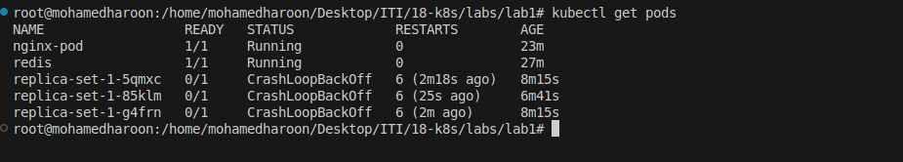

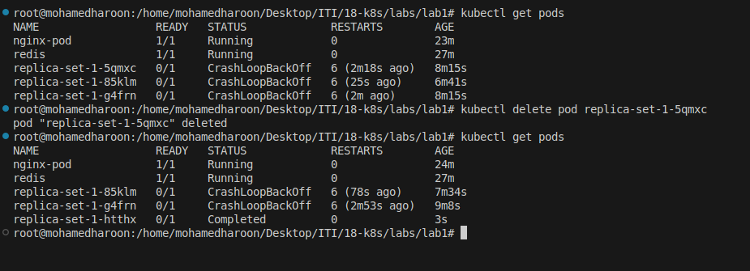
- Delete any one of the 3 PODs then check How many PODs exist now?
Why are there still 3 PODs, even after you deleted one?

How many Deployments and ReplicaSets exist on the system?
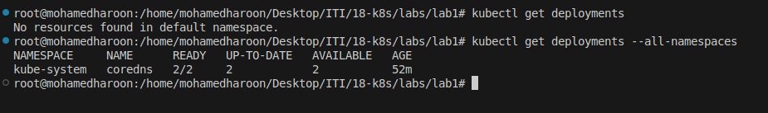

create a Deployment with name= deployment-1 image= busybox replicas= 3

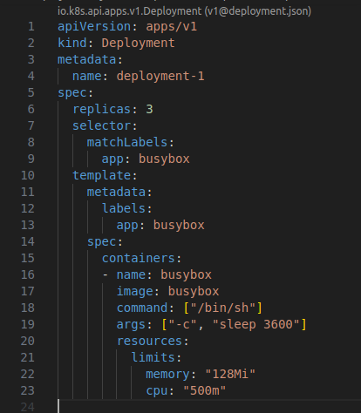

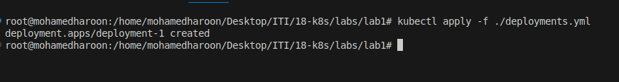

How many Deployments and ReplicaSets exist on the system now?
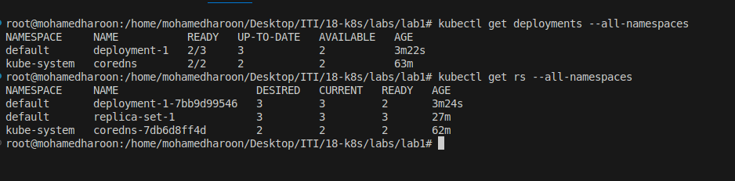

How many pods are ready with the deployment-1?

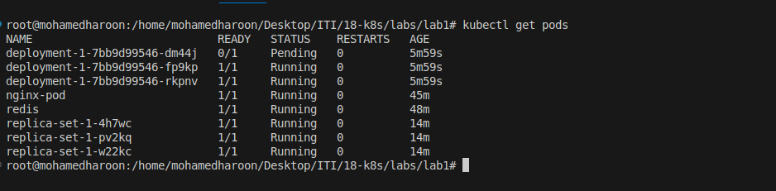

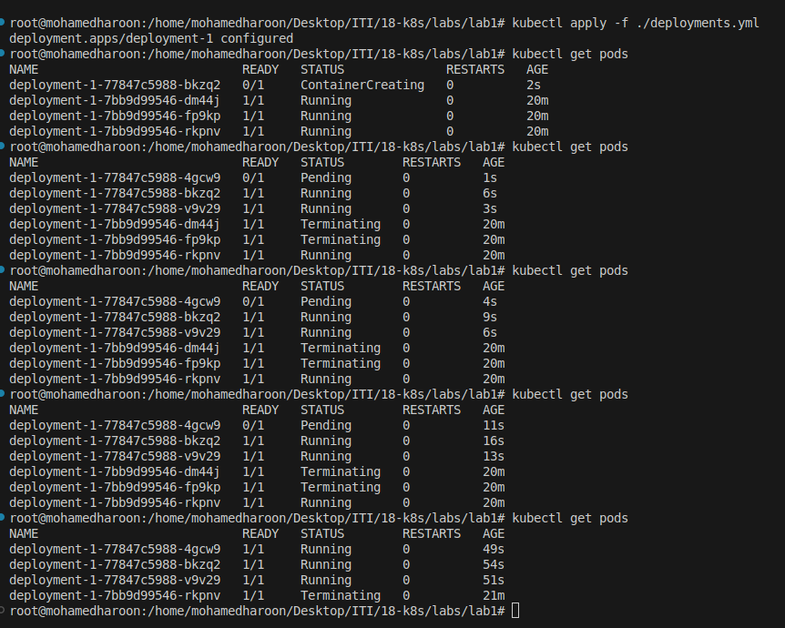
Update deployment-1 image to nginx then check the ready pods again

Run kubectl describe deployment deployment-1 and check events
What is the deployment strategy used to upgrade the deployment-1?

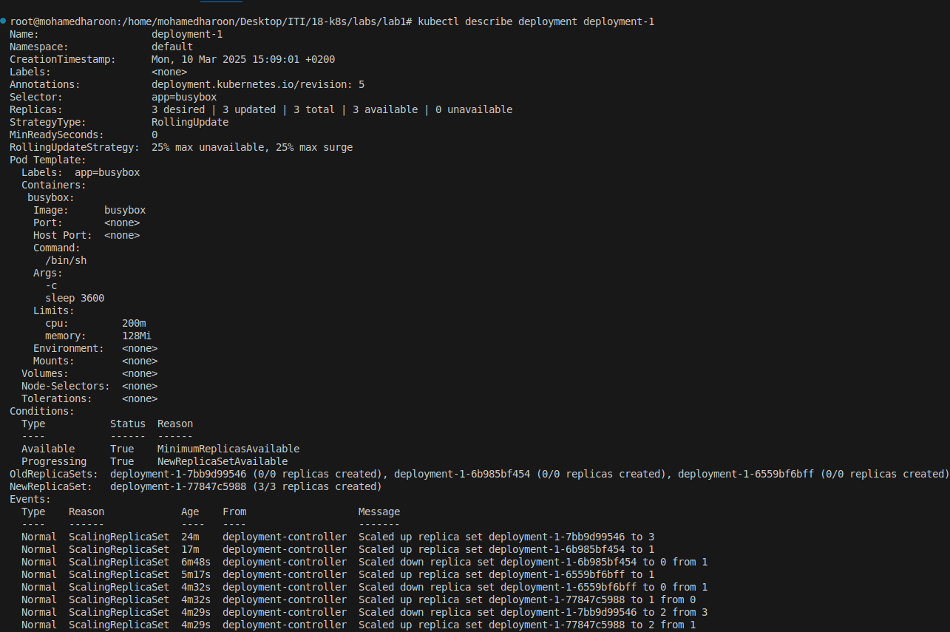

Rollback the deployment-1 What is the used image with the deployment-1?
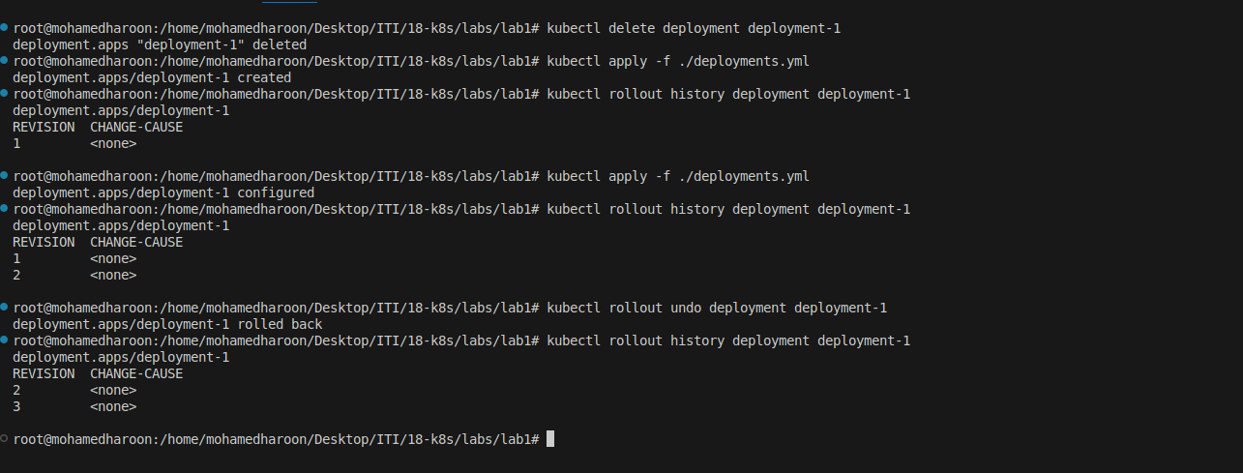

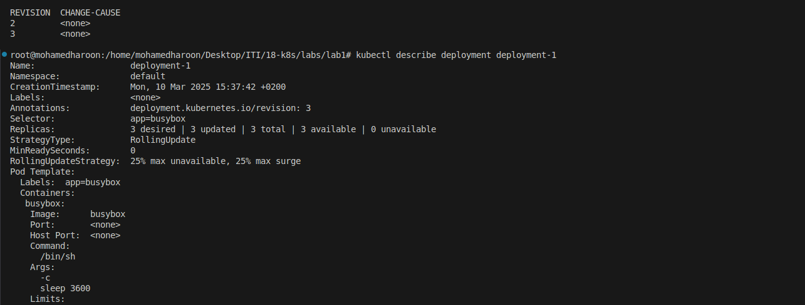

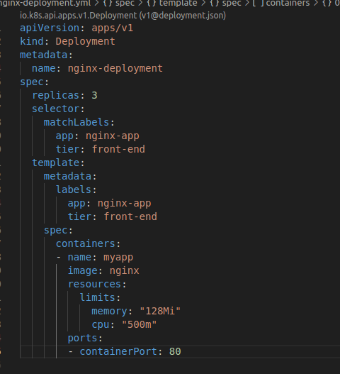
Create a deployment using nginx image with latest tag only and remember to
mention tag i.e nginx:latest and name it as nginx-deployment. App labels should
be app: nginx-app and type: front-end. The container should be named as
nginx-container; also make sure replica counts are

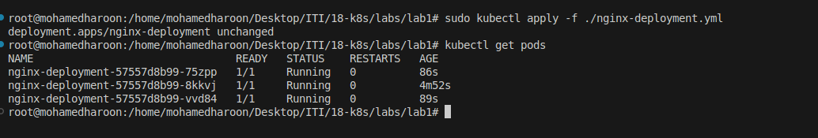

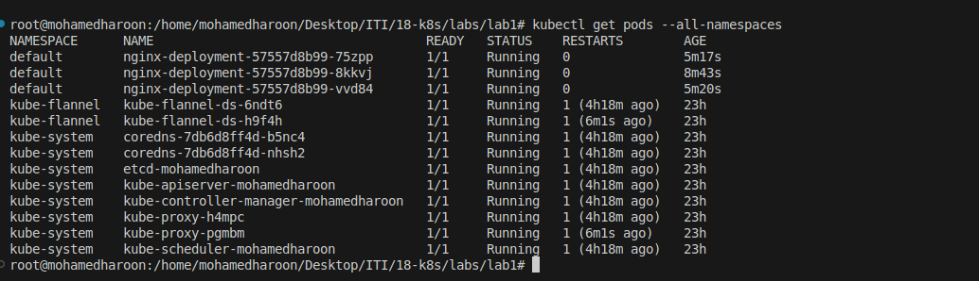
How many static pods exist in this cluster?

create a static pod nginx

